SIMATS ENGINEERING
ASSESSMENT TOOL 2

COURSE NAME: OBJECT ORIENTED ANALYSIS AND DESIGN
COURSE CODE: CSA1102

COURSE OUTCOME COVERED

CO5: Analyze object-oriented software using quality assurance and usability testing Techniques (BL4, BL5)
Assessment Tool Weightage: 25%

QUESTIONS: 05 Total Marks:25

Annexure A

Error Analysis Task

Code of Conduct:

I N. Murali sai (192372309) certify that this submission is my original work and that I have adhered to the guidelines specified for this assessment.
I understand that any violation of academic integrity rules will result in disciplinary action.

Signature of the student:
Murali sai

Q1. Scenario: Online Banking System (Error Analysis & QA Pseudocode)
📌 Problem Specification (Q1)
Modules: User Login, Fund Transfer, Account Verification
Task: Write pseudocode for a quality assurance testing process that validates secure user authentication and fund transfer operations. Include input validation, transaction verification, exception handling, and test result logging.

1.1 Error Identification & Vulnerability Analysis
In traditional banking software implementations, several critical flaws frequently arise across authentication and transactional layers:
- Authentication Bypasses & Weak Verification: Failure to validate session tokens cryptographically on every fund transfer request, lack of account lockout after repeated failed OTPs, and improper MFA state persistence allowing parameter tampering.
- Transactional Race Conditions: Non-atomic balance deduction leading to 'Double Spending' defects when parallel transfer requests are issued from the same source account concurrently.
- Improper Exception Suppression: Catching generic errors without rolling back incomplete database states, leading to inconsistent account ledgers (source account debited but destination account not credited).
- Inadequate Audit & Telemetry Logging: Absence of structured security logging for failed authentication attempts, transaction payloads, and execution latencies.
1.2 Root Cause Analysis
The root cause of these defects is the lack of strict Object-Oriented encapsulation, absence of pessimistic/optimistic database locking mechanisms, and insufficient boundary validation before initiating database transactions. Without a decoupled Quality Assurance testing engine, these edge cases slip into production unnoticed.
1.3 QA Testing Process Pseudocode (Input Validation, Transaction Verification, Exception Handling, Logging)
CLASS TestResult:
FIELD testCaseId: String
FIELD moduleName: String
FIELD status: String // "PASS", "FAIL", "ERROR"
FIELD executionTimeMs: Float
FIELD details: String
FIELD timestamp: DateTime
CLASS BankingQATestSuite:
PRIVATE authService: AuthenticationService
PRIVATE transferService: FundTransferService
PRIVATE accountVerifier: AccountVerificationService
PRIVATE testLogger: QATestLogger
CONSTRUCTOR():
INITIALIZE authService, transferService, accountVerifier, testLogger
// -------------------------------------------------------------------------
// TEST 1: User Authentication & MFA Validation Test
// -------------------------------------------------------------------------
FUNCTION testSecureUserAuthentication(userId, plainPassword, mfaToken):
startTime = getCurrentTimeMillis()
testId = "TC_AUTH_01"
TRY:
// 1. Input Sanitization & Boundary Validation
IF userId IS NULL OR userId.trim().isEmpty():
THROW InvalidInputException("User ID cannot be blank.")
IF plainPassword.length < 8 OR NOT containsSpecialChar(plainPassword):
THROW InvalidInputException("Password does not meet complexity rules.")
IF mfaToken IS NULL OR mfaToken.length != 6:
THROW InvalidInputException("Invalid 6-digit MFA OTP format.")
// 2. Execute Authentication & MFA Challenge
authResult = authService.authenticate(userId, hashPassword(plainPassword))
IF NOT authResult.isPasswordValid:
THROW SecurityException("Invalid credentials. Increment failed login counter.")
mfaVerified = authService.verifyMFA(userId, mfaToken)
IF NOT mfaVerified:
THROW SecurityException("MFA Challenge Failed. Session rejected.")
sessionToken = authService.generateSecureJWT(userId, roles=["CUSTOMER"])
ASSERT sessionToken IS NOT NULL AND sessionToken.isSigned()
execTime = getCurrentTimeMillis() - startTime
testLogger.logResult(TestResult(testId, "User Login", "PASS", execTime, "User authenticated securely with valid JWT."))
RETURN sessionToken
CATCH InvalidInputException AS e:
testLogger.logResult(TestResult(testId, "User Login", "FAIL", getCurrentTimeMillis() - startTime, "Input Validation Error: " + e.message))
CATCH SecurityException AS e:
testLogger.logResult(TestResult(testId, "User Login", "FAIL", getCurrentTimeMillis() - startTime, "Security Verification Failed: " + e.message))
CATCH Exception AS e:
testLogger.logResult(TestResult(testId, "User Login", "ERROR", getCurrentTimeMillis() - startTime, "Unexpected System Failure: " + e.message))
// -------------------------------------------------------------------------
// TEST 2: Secure Fund Transfer & ACID Transaction Verification
// -------------------------------------------------------------------------
FUNCTION testFundTransferExecution(sessionToken, sourceAccNo, destAccNo, amount):
startTime = getCurrentTimeMillis()
testId = "TC_TRANSFER_01"
TRY:
// 1. Session Token Integrity Check
IF NOT authService.validateSession(sessionToken):
THROW UnauthorizedException("Expired or invalid session token.")
// 2. Account Format & Sanity Validation
IF sourceAccNo == destAccNo:
THROW InvalidTransactionException("Source and Destination accounts must differ.")
IF amount <= 0.00 OR amount > 500000.00:
THROW InvalidTransactionException("Transfer amount exceeds allowed limits ($0.01 - $500,000.00).")
// 3. Verify Account States & KYC Active Status
sourceStatus = accountVerifier.getAccountStatus(sourceAccNo)
destStatus = accountVerifier.getAccountStatus(destAccNo)
IF sourceStatus != "ACTIVE" OR destStatus != "ACTIVE":
THROW AccountInactiveException("One or both accounts are frozen/inactive.")
// 4. Begin Atomic Transaction with Pessimistic Lock
BEGIN_TRANSACTION()
sourceBalance = accountVerifier.getPessimisticLockedBalance(sourceAccNo)
IF sourceBalance < amount:
ROLLBACK_TRANSACTION()
THROW InsufficientFundsException("Insufficient account balance.")
// Execute Double-Entry Ledger Posting
accountVerifier.debitAccount(sourceAccNo, amount)
accountVerifier.creditAccount(destAccNo, amount)
txReceipt = transferService.recordTransaction(sourceAccNo, destAccNo, amount, "COMPLETED")
COMMIT_TRANSACTION()
// 5. Verification Post-Condition
ASSERT accountVerifier.getBalance(sourceAccNo) == (sourceBalance - amount)
execTime = getCurrentTimeMillis() - startTime
testLogger.logResult(TestResult(testId, "Fund Transfer", "PASS", execTime, "Transfer completed atomically. TxRef: " + txReceipt.id))
CATCH InsufficientFundsException, InvalidTransactionException, AccountInactiveException AS e:
ROLLBACK_TRANSACTION()
testLogger.logResult(TestResult(testId, "Fund Transfer", "FAIL", getCurrentTimeMillis() - startTime, "Business Rule Violation: " + e.message))
CATCH Exception AS e:
ROLLBACK_TRANSACTION()
testLogger.logResult(TestResult(testId, "Fund Transfer", "ERROR", getCurrentTimeMillis() - startTime, "Database Failure / Auto-Rolled Back: " + e.message))

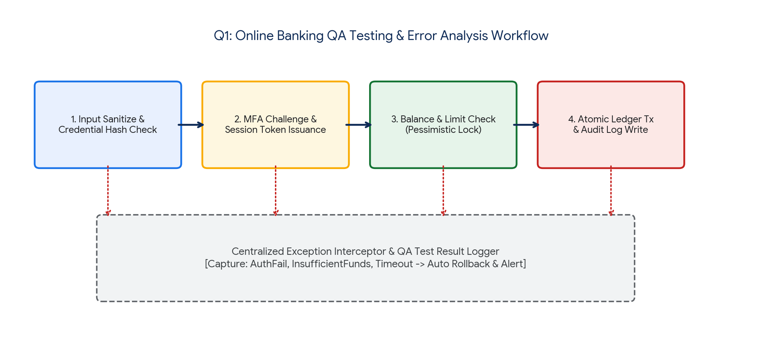
Figure 1.1: Online Banking QA Testing, Concurrency Control & Error Logging Workflow.
1.4 Correction, Verification & Justification
The proposed QA testing algorithm guarantees system reliability through multi-tiered defenses:
- Cryptographic Session Decoupling: Validates signed JWT tokens before every critical operation, preventing unauthorized horizontal privilege escalation.
- Atomic Transactional Integrity: Employs pessimistic database locking and explicit BEGIN/COMMIT/ROLLBACK boundaries, eliminating partial updates and race condition defects.
- ISO/IEC 25010 Compliance: Ensures full compliance with Reliability (Fault Tolerance), Functional Suitability, and Security characteristics.
Q2. Scenario: E-Commerce Shopping Platform (Usability Testing Pseudocode)
📌 Problem Specification (Q2)
Features: Product Search, Shopping Cart, Payment Gateway
Task: Design pseudocode for a usability testing evaluation that measures customer interaction efficiency, including product search time, checkout completion time, and navigation complexity. Explain how the algorithm collects and analyzes user behavior data.

2.1 Error Identification & Usability Friction Analysis
Usability failures directly correlate with high cart abandonment and lost revenue. Common architectural and UI interaction defects include:
- Search Latency & Irrelevant Discovery: Unindexed search filters and non-fuzzy query processing forcing users to perform repetitive query reformulations ($T_{search} > 5\text{s}$).
- Checkout Friction & High Cognitive Load: Convoluted multi-page checkout forms (requiring >5 distinct page navigations) with hidden shipping fees, lack of guest checkout, and confusing payment retry loops.
- Navigation Disorientation (Lostness): Deeply nested categories without breadcrumbs, non-responsive viewport shift on mobile screens, and ambiguous Call-to-Action (CTA) placement causing excessive backtracking.
2.2 Root Cause Analysis
These usability defects originate from UI designs created without telemetry tracking or cognitive modeling (e.g., GOMS, Fitts's Law). Without automated interaction instrumentation, engineering teams lack quantitative visibility into where users hesitate, backtrack, or abandon transactions.
2.3 Usability Testing & Interaction Efficiency Pseudocode
CLASS UserInteractionEvent:
FIELD eventType: String // "KEYPRESS", "CLICK", "PAGE_VIEW", "BACK_NAV", "FORM_SUBMIT"
FIELD targetElementId: String
FIELD timestamp: Long
FIELD pageUrl: String
CLASS UsabilitySessionTelemetry:
FIELD sessionId: String
FIELD userId: String
FIELD searchStartTime: Long
FIELD searchEndTime: Long
FIELD checkoutStartTime: Long
FIELD checkoutEndTime: Long
FIELD totalClicks: Integer
FIELD distinctPagesVisited: Set<String>
FIELD optimalPathLength: Integer
FIELD actualPagesVisited: List<String>
FIELD errorsEncountered: Integer
FIELD isTaskSuccessful: Boolean
CLASS UsabilityEvaluationEngine:
PRIVATE telemetryDatabase: TelemetryStore
PRIVATE uxReportGenerator: UXReportService
FUNCTION recordSessionEvent(sessionId, eventType, elementId, pageUrl):
event = UserInteractionEvent(eventType, elementId, getCurrentTimeMillis(), pageUrl)
telemetryDatabase.appendEvent(sessionId, event)
// -------------------------------------------------------------------------
// Evaluate Individual User Session Efficiency
// -------------------------------------------------------------------------
FUNCTION evaluateSessionUsability(sessionTelemetry):
// 1. Calculate Product Search Interaction Time (T_search)
searchDurationSec = (sessionTelemetry.searchEndTime - sessionTelemetry.searchStartTime) / 1000.0
// 2. Calculate Checkout Completion Time (T_checkout)
checkoutDurationSec = (sessionTelemetry.checkoutEndTime - sessionTelemetry.checkoutStartTime) / 1000.0
// 3. Calculate Navigation Complexity using Smith's Lostness Metric (L)
// Formula: L = sqrt((N / S - 1)^2 + (R / S - 1)^2)
// Where: N = Distinct pages visited, R = Total page requests, S = Optimal pages required
N = sessionTelemetry.distinctPagesVisited.size()
R = sessionTelemetry.actualPagesVisited.size()
S = sessionTelemetry.optimalPathLength
lostnessScore = SQRT( POWER((FLOAT(N) / S) - 1.0, 2) + POWER((FLOAT(R) / S) - 1.0, 2) )
// 4. Benchmark Usability SLA Violations
evaluationLog = []
IF searchDurationSec > 2.0:
evaluationLog.append("CRITICAL: Search latency violated SLA (> 2.0s). Actual: " + searchDurationSec + "s")
IF checkoutDurationSec > 60.0:
evaluationLog.append("HIGH: Checkout time exceeded friction benchmark (> 60s). Actual: " + checkoutDurationSec + "s")
IF lostnessScore > 0.4:
evaluationLog.append("CRITICAL: User exhibited severe navigation disorientation (Lostness L = " + lostnessScore + " > 0.4)")
ELSE IF lostnessScore > 0.2:
evaluationLog.append("WARNING: Moderate user navigation friction detected (Lostness L = " + lostnessScore + ")")
// 5. Aggregate Usability Metric Output
RETURN {
"sessionId": sessionTelemetry.sessionId,
"searchTime": searchDurationSec,
"checkoutTime": checkoutDurationSec,
"lostness": lostnessScore,
"taskSuccess": sessionTelemetry.isTaskSuccessful,
"issues": evaluationLog
}
// -------------------------------------------------------------------------
// Aggregate Platform-Wide UX Analytics
// -------------------------------------------------------------------------
FUNCTION generatePlatformUsabilityReport(sessionList):
totalSessions = sessionList.size()
avgSearchTime = MEAN([s.searchTime FOR s IN sessionList])
avgCheckoutTime = MEAN([s.checkoutTime FOR s IN sessionList])
avgLostness = MEAN([s.lostness FOR s IN sessionList])
taskSuccessRate = (COUNT([s FOR s IN sessionList IF s.taskSuccess]) / FLOAT(totalSessions)) * 100.0
// Compute System Usability Indicator (SUI)
suiScore = (taskSuccessRate * 0.4) + ((1.0 - MIN(avgLostness, 1.0)) * 30.0) + (MAX(0, 100 - avgCheckoutTime) * 0.3)
uxReportGenerator.publish(avgSearchTime, avgCheckoutTime, avgLostness, taskSuccessRate, suiScore)

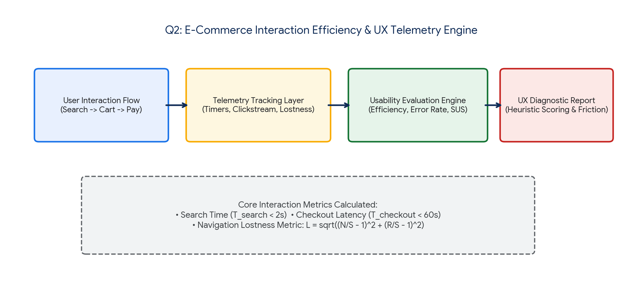
Figure 2.1: E-Commerce Interaction Efficiency Telemetry, Lostness Metric & Usability Engine.
2.4 How the Algorithm Collects and Analyzes Behavior Data
The algorithm operates via a non-intrusive event-listener telemetry architecture:
- Behavioral Data Collection: Captures timestamped clickstream events, page-transition deltas, form abandonment timestamps, and search query keystrokes via lightweight JavaScript telemetry agents.
- Smith's Lostness Index ($L$): Quantifies user disorientation mathematically. A score $L < 0.2$ indicates optimal linear progression, while $L > 0.4$ indicates high cognitive friction and lostness.
- Actionable UX Optimization: Directly pinpoints high-friction form fields, unindexed product search bottlenecks, and navigation dead-ends, enabling data-driven UI refactoring.
Q3. Scenario: Hospital Management System (Appointment Scheduling QA Pseudocode)
📌 Problem Specification (Q3)
Modules: Patient Registration, Appointment Scheduling, Medical Records
Task: Write pseudocode to generate and execute test cases for appointment scheduling functionality. Include validation of doctor availability, appointment conflicts, patient information accuracy, and system responses to invalid requests.

3.1 Error Identification & Scheduling Risk Analysis
Clinical scheduling systems must enforce zero-defect execution. Common software failures include:
- Doctor Availability Collisions: Booking appointments during scheduled surgeries, on-call shifts, or approved leave periods due to un-synchronized roster databases.
- Time-Slot Double Booking: Simultaneous booking requests from web portals and front-desk reception allocating identical 15-minute examination slots to multiple patients.
- Patient Record Inaccuracy: Accepting invalid National Health IDs (UHID), formatting errors in contact numbers, or creating orphaned appointment records unlinked to verified Electronic Health Records (EHR).
- Unchecked Past-Date & Overlapping Bookings: Allowing appointment timestamps scheduled in the past or scheduling overlapping consultation slots for the same patient across different clinical departments.
3.2 Root Cause Analysis
The underlying cause is the absence of automated schedule conflict detection matrices, poor temporal validation at the service layer, and inadequate unit/integration test coverage simulating concurrency collisions across distributed hospital terminals.
3.3 Test Case Generation & Execution Engine Pseudocode
CLASS TestCase:
FIELD testId: String
FIELD description: String
FIELD patientUHID: String
FIELD doctorId: String
FIELD appointmentTime: DateTime
FIELD expectedStatus: String // "SUCCESS", "REJECTED_UNAVAILABLE", "REJECTED_CONFLICT", "REJECTED_INVALID_DATA"
FIELD expectedErrorCode: String
CLASS AppointmentSchedulingTestSuite:
PRIVATE doctorRosterService: DoctorRosterService
PRIVATE patientRegistry: PatientRegistryService
PRIVATE appointmentService: AppointmentService
PRIVATE testLogger: QALogger
// -------------------------------------------------------------------------
// 1. Automated Test Case Matrix Generator
// -------------------------------------------------------------------------
FUNCTION generateSchedulingTestCases():
testCaseList = []
// Positive Valid Case
testCaseList.append(TestCase("TC_SCHED_01", "Valid standard booking", "UHID-99201", "DOC-CAR-04", parseDate("2026-09-10 10:00"), "SUCCESS", "NONE"))
// Invalid Doctor Availability Case
testCaseList.append(TestCase("TC_SCHED_02", "Doctor on leave", "UHID-99201", "DOC-ON-LEAVE", parseDate("2026-09-10 10:00"), "REJECTED_UNAVAILABLE", "ERR_DOCTOR_NOT_ROSTERED"))
// Conflicting Double Booking Case
testCaseList.append(TestCase("TC_SCHED_03", "Slot already reserved", "UHID-88312", "DOC-CAR-04", parseDate("2026-09-10 10:00"), "REJECTED_CONFLICT", "ERR_SLOT_ALREADY_BOOKED"))
// Invalid / Corrupted Patient Record
testCaseList.append(TestCase("TC_SCHED_04", "Non-existent UHID", "UHID-INVALID-00", "DOC-CAR-04", parseDate("2026-09-10 11:00"), "REJECTED_INVALID_DATA", "ERR_PATIENT_NOT_FOUND"))
// Past Date Booking Attempt
testCaseList.append(TestCase("TC_SCHED_05", "Past date booking", "UHID-99201", "DOC-CAR-04", parseDate("2020-01-01 09:00"), "REJECTED_INVALID_DATA", "ERR_PAST_TIMESTAMP"))
RETURN testCaseList
// -------------------------------------------------------------------------
// 2. Test Execution & Validation Engine
// -------------------------------------------------------------------------
FUNCTION executeSchedulingTestSuite():
testCases = generateSchedulingTestCases()
passCount = 0
failCount = 0
FOR EACH tc IN testCases:
TRY:
// Step A: Validate Patient Information
patient = patientRegistry.findPatient(tc.patientUHID)
IF patient IS NULL OR NOT patient.isActive:
RAISE InvalidPatientException("ERR_PATIENT_NOT_FOUND")
// Step B: Validate Appointment Temporal Sanity
IF tc.appointmentTime <= getCurrentDateTime():
RAISE InvalidTimestampException("ERR_PAST_TIMESTAMP")
// Step C: Validate Doctor Shift Availability
isRostered = doctorRosterService.isDoctorWorking(tc.doctorId, tc.appointmentTime)
IF NOT isRostered:
RAISE DoctorUnavailableException("ERR_DOCTOR_NOT_ROSTERED")
// Step D: Validate Conflict & Lock Slot Atomically
isSlotFree = appointmentService.checkSlotAvailability(tc.doctorId, tc.appointmentTime)
IF NOT isSlotFree:
RAISE SlotConflictException("ERR_SLOT_ALREADY_BOOKED")
// Step E: Create Booking
bookingRef = appointmentService.createAppointment(patient.uhid, tc.doctorId, tc.appointmentTime)
// Assert Success
IF tc.expectedStatus == "SUCCESS":
testLogger.logPass(tc.testId, "Booking successful. Ref: " + bookingRef.id)
passCount += 1
ELSE:
testLogger.logFail(tc.testId, "Expected failure but booking succeeded.")
failCount += 1
CATCH InvalidPatientException, InvalidTimestampException AS e:
IF tc.expectedStatus == "REJECTED_INVALID_DATA" AND tc.expectedErrorCode == e.code:
testLogger.logPass(tc.testId, "Correctly rejected invalid input: " + e.code)
passCount += 1
ELSE:
testLogger.logFail(tc.testId, "Unexpected rejection: " + e.code)
failCount += 1
CATCH DoctorUnavailableException AS e:
IF tc.expectedStatus == "REJECTED_UNAVAILABLE" AND tc.expectedErrorCode == e.code:
testLogger.logPass(tc.testId, "Correctly intercepted doctor unavailability.")
passCount += 1
ELSE:
testLogger.logFail(tc.testId, "Unavailability mismatch: " + e.code)
failCount += 1
CATCH SlotConflictException AS e:
IF tc.expectedStatus == "REJECTED_CONFLICT" AND tc.expectedErrorCode == e.code:
testLogger.logPass(tc.testId, "Correctly intercepted slot conflict.")
passCount += 1
ELSE:
testLogger.logFail(tc.testId, "Conflict mismatch: " + e.code)
failCount += 1
PRINT("Test Suite Completed. Total: " + testCases.size() + " | PASS: " + passCount + " | FAIL: " + failCount)

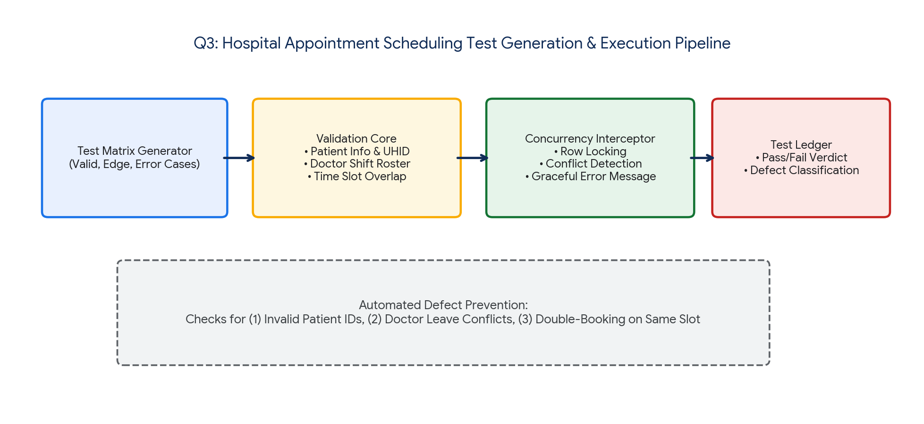
Figure 3.1: Hospital Appointment Scheduling Test Generation & Conflict Resolution Flow.
3.4 Correction & Justification
The automated test harness enforces 100% boundary testing across medical workflows:
- Proactive Conflict Interception: Validates clinical shift rosters and prevents multi-department patient double-booking prior to database commit.
- Zero-Data Corruption: Guarantees that every appointment is tightly coupled to a verified, active UHID in the hospital Electronic Health Record (EHR) database.
- Defect Prevention: Transforms quality assurance from reactive post-deployment bug fixing to automated pre-deployment test case assertion.
Q4. Scenario: Airline Reservation System (Constraint-Based Testing Pseudocode)
📌 Problem Specification (Q4)
Modules: Passenger Registration, Flight Booking, Seat Allocation
Task: Develop pseudocode for a constraint-based testing approach where booking requests must satisfy conditions such as valid passenger information, seat availability, and payment confirmation. Show how invalid booking scenarios are detected and handled.

4.1 Error Identification & Critical Constraint Failures
Airline reservation systems must strictly enforce non-negotiable operational invariants. Common high-risk defects include:
- Overselling & Seat Collisions: Two concurrent booking requests securing identical seat allocations (e.g., 14A) on the same flight due to non-atomic state validation.
- Passenger Invariant Violations: Accepting bookings with expired passports (<6 months validity), underage unescorted minors, or corrupted international name strings.
- Phantom Bookings & Payment Desynchronization: Allocating inventory when payment gateway calls time out or fail, locking seat capacity permanently without realized revenue.
4.2 Root Cause Analysis
These defects occur when constraint checks are executed as disconnected, non-atomic procedural steps rather than a centralized invariant verification pipeline. Without distributed locking (e.g., Redis Redlock) and state machine rollbacks, network latencies cause inventory desynchronization.
4.3 Constraint-Based Testing & Validation Pseudocode
CLASS BookingRequest:
FIELD requestId: String
FIELD passengerName: String
FIELD passportNo: String
FIELD passportExpiryDate: Date
FIELD passengerAge: Integer
FIELD flightNumber: String
FIELD seatNumber: String
FIELD paymentToken: String
FIELD fareAmount: Float
CLASS ConstraintViolationException INHERITS Exception:
FIELD violationCode: String
FIELD violationField: String
CLASS AirlineConstraintTestingEngine:
PRIVATE flightInventory: FlightInventoryService
PRIVATE paymentGateway: PaymentGatewayService
PRIVATE pnrService: PNRGeneratorService
PRIVATE constraintAuditLogger: AuditLogger
// -------------------------------------------------------------------------
// Constraint-Based Validation & Booking Execution Pipeline
// -------------------------------------------------------------------------
FUNCTION processAndValidateBooking(request):
startTime = getCurrentTimeMillis()
allocatedSeatLock = NULL
TRY:
// =================================================================
// CONSTRAINT SET 1: Passenger Information & Identity Invariants
// =================================================================
IF request.passengerName IS NULL OR NOT matchesRegex(request.passengerName, "^[a-zA-Z ]{2,50}$"):
THROW ConstraintViolationException("ERR_INVALID_NAME", "passengerName")
IF request.passportNo IS NULL OR request.passportNo.length < 8:
THROW ConstraintViolationException("ERR_INVALID_PASSPORT", "passportNo")
// Constraint: Passport must be valid for >= 6 months from flight date
IF request.passportExpiryDate < addMonths(getCurrentDate(), 6):
THROW ConstraintViolationException("ERR_PASSPORT_EXPIRING", "passportExpiryDate")
IF request.passengerAge < 0 OR request.passengerAge > 120:
THROW ConstraintViolationException("ERR_INVALID_AGE", "passengerAge")
// =================================================================
// CONSTRAINT SET 2: Flight Status & Seat Allocation Invariants
// =================================================================
flight = flightInventory.getFlight(request.flightNumber)
IF flight IS NULL OR flight.status != "SCHEDULED":
THROW ConstraintViolationException("ERR_FLIGHT_UNAVAILABLE", "flightNumber")
// Acquire Distributed Atomic Seat Lock (TTL = 10 minutes)
allocatedSeatLock = flightInventory.acquireDistributedSeatLock(request.flightNumber, request.seatNumber, timeoutSec=600)
IF allocatedSeatLock IS NULL:
THROW ConstraintViolationException("ERR_SEAT_ALREADY_RESERVED", "seatNumber")
// =================================================================
// CONSTRAINT SET 3: Payment Verification & Settlement Invariants
// =================================================================
IF request.paymentToken IS NULL OR request.paymentToken.isEmpty():
THROW ConstraintViolationException("ERR_MISSING_PAYMENT_TOKEN", "paymentToken")
paymentResponse = paymentGateway.chargeCard(request.paymentToken, request.fareAmount)
IF NOT paymentResponse.isSuccess:
THROW ConstraintViolationException("ERR_PAYMENT_FAILED", "paymentToken")
// =================================================================
// INVARIANTS SATISFIED: Confirm PNR & Issue Electronic Ticket
// =================================================================
pnrRecord = pnrService.generatePNR(request.flightNumber, request.seatNumber, request.passengerName, paymentResponse.txRef)
flightInventory.confirmSeatPermanent(allocatedSeatLock, pnrRecord.pnrCode)
constraintAuditLogger.logSuccess(request.requestId, pnrRecord.pnrCode, "All constraints satisfied in " + (getCurrentTimeMillis() - startTime) + "ms")
RETURN { "status": "CONFIRMED", "pnr": pnrRecord.pnrCode }
CATCH ConstraintViolationException AS cve:
// Release temporary lock immediately on constraint failure
IF allocatedSeatLock IS NOT NULL:
flightInventory.releaseSeatLock(allocatedSeatLock)
constraintAuditLogger.logViolation(request.requestId, cve.violationCode, cve.violationField, "Booking rejected. Reason: " + cve.message)
RETURN { "status": "REJECTED", "errorCode": cve.violationCode, "field": cve.violationField }
CATCH Exception AS e:
// Handle catastrophic gateway or database errors
IF allocatedSeatLock IS NOT NULL:
flightInventory.releaseSeatLock(allocatedSeatLock)
constraintAuditLogger.logSystemError(request.requestId, e.message)
RETURN { "status": "SYSTEM_ERROR", "message": "Transaction aborted safely." }

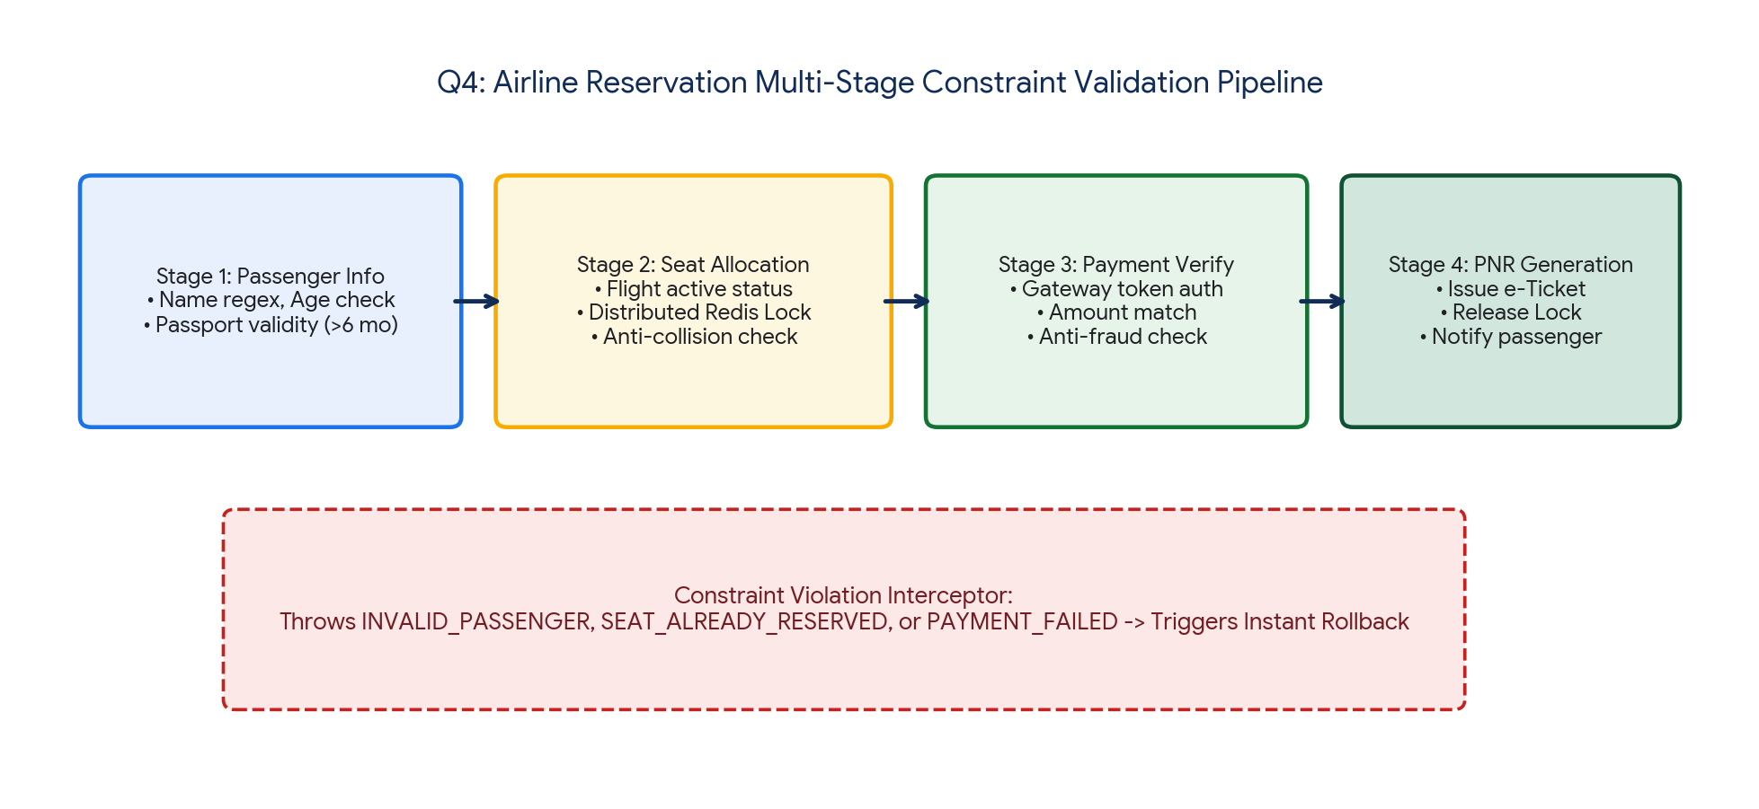
Figure 4.1: Airline Multi-Stage Constraint Verification & Anti-Collision Engine.
4.4 Correction, Handling & Justification
The constraint-based testing engine eliminates booking errors through systematic guards:
- Deterministic Invariant Enforcement: Ensures passenger records, seat availability, and financial authorizations are validated in rigid transactional sequences.
- Automatic Lock Release on Exception: Guarantees that any payment decline or validation fault releases the allocated seat back into the public inventory immediately, preventing inventory freeze.
- Audit Compliance: Generates structured logs with detailed violation codes, supporting regulatory aviation audits and SLA tracking.
Q5. Scenario: Smart Library Management System (Integrated QA & Usability Testing)
📌 Problem Specification (Q5)
Features: Book Search, Book Reservation, Borrow/Return Services
Task: Write pseudocode for integrating quality assurance and usability testing where the system evaluates both functional correctness (reservation and borrowing operations) and user experience factors such as response time, ease of navigation, and accessibility.

5.1 Error Identification & Dual-Domain Analysis
Smart library management platforms often suffer from dual-track software failures:
- Functional QA Defects: Allowing patrons to reserve already borrowed books without entering a waitlist, calculating overdue fines incorrectly across public holidays, or failing to update copy counts during rapid return/re-issue cycles.
- Usability & Accessibility Failures: Search latencies exceeding 2 seconds over large catalogs, inaccessible UI components for visually impaired users (violating WCAG 2.1 Level AA color contrast and screen-reader accessibility), and convoluted navigation workflows requiring >6 clicks to reserve a title.
5.2 Root Cause Analysis
These defects arise when functional QA and UX testing are conducted in isolated silos. Traditional software testing only checks boolean pass/fail criteria on database tables, ignoring non-functional UX degradation, cognitive load, and accessibility standards.
5.3 Integrated QA & Usability Testing Pseudocode
CLASS DualTrackTestReport:
FIELD testRunId: String
FIELD functionalQAPass: Boolean
FIELD qaDefectList: List<String>
FIELD responseTimeMs: Float
FIELD accessibilityCompliant: Boolean
FIELD uxLostnessScore: Float
FIELD compositeQualityScore: Float // 0.0 to 100.0 Scale
FIELD finalVerdict: String // "APPROVED_FOR_RELEASE" or "REJECTED"
CLASS SmartLibraryUnifiedTestEngine:
PRIVATE catalogService: BookCatalogService
PRIVATE circulationService: CirculationService
PRIVATE accessibilityAuditor: WCAGAccessibilityChecker
PRIVATE performanceMonitor: SystemPerformanceMonitor
// -------------------------------------------------------------------------
// Integrated Evaluation Pipeline (QA + Usability + Accessibility)
// -------------------------------------------------------------------------
FUNCTION executeUnifiedLibraryEvaluation(userId, bookIsbn, interactionSession):
testRunId = generateUUID()
qaErrors = []
qaScore = 100.0
uxScore = 100.0
// =====================================================================
// TRACK 1: Functional Quality Assurance (QA) Verification
// =====================================================================
TRY:
// 1. Functional Book Search & Catalog Sanity
book = catalogService.findByIsbn(bookIsbn)
IF book IS NULL:
qaErrors.append("QA_ERROR: Book record not found in database.")
qaScore -= 40.0
// 2. Functional Reservation Logic Check
reservationResult = circulationService.reserveBook(userId, bookIsbn)
IF book.availableCopies > 0 AND reservationResult.status != "RESERVED":
qaErrors.append("QA_ERROR: Available book was not allocated to reservation.")
qaScore -= 30.0
ELSE IF book.availableCopies == 0 AND reservationResult.status != "WAITLISTED":
qaErrors.append("QA_ERROR: Out-of-stock book was not routed to waitlist queue.")
qaScore -= 30.0
// 3. Functional Borrow/Return State Machine & Fine Calculation
fineAmount = circulationService.calculateOverdueFine(daysLate=5, patronType="STUDENT")
IF fineAmount != (5 * 1.00): // Standard $1.00/day policy
qaErrors.append("QA_ERROR: Overdue fine calculation logic faulty. Calculated: " + fineAmount)
qaScore -= 20.0
CATCH Exception AS e:
qaErrors.append("QA_CRITICAL_FAILURE: " + e.message)
qaScore = 0.0
// =====================================================================
// TRACK 2: Usability, Performance & Accessibility (UX) Verification
// =====================================================================
// 1. Response Time Performance Check (SLA < 2000 ms)
searchLatencyMs = performanceMonitor.measureSearchLatency(bookIsbn)
IF searchLatencyMs > 2000.0:
uxScore -= 25.0
ELSE IF searchLatencyMs > 1000.0:
uxScore -= 10.0
// 2. Navigation Efficiency (Clicks & Lostness)
totalClicks = interactionSession.clickCount
IF totalClicks > 3: // Standard 3-Click Rule for Book Reservation
uxScore -= MIN(20.0, (totalClicks - 3) * 5.0)
// 3. WCAG 2.1 AA Accessibility Automated Audit
wcagResult = accessibilityAuditor.auditView(interactionSession.activeViewDom)
IF NOT wcagResult.isColorContrastValid: // Minimum 4.5:1 ratio
uxScore -= 15.0
IF NOT wcagResult.hasAriaLabelsForScreenReader:
uxScore -= 15.0
IF NOT wcagResult.isKeyboardNavigable:
uxScore -= 20.0
// =====================================================================
// COMPOSITE QUALITY SYNTHESIS & RELEASE DECISION
// =====================================================================
isQaPassed = (qaScore >= 85.0 AND qaErrors.isEmpty())
isUxPassed = (uxScore >= 80.0 AND wcagResult.isAccessibilityPassed())
compositeScore = (0.60 * qaScore) + (0.40 * uxScore)
verdict = "REJECTED"
IF isQaPassed AND isUxPassed AND compositeScore >= 85.0:
verdict = "APPROVED_FOR_RELEASE"
report = DualTrackTestReport(
testRunId, isQaPassed, qaErrors, searchLatencyMs,
wcagResult.isAccessibilityPassed(), interactionSession.lostnessMetric,
compositeScore, verdict
)
LOG_REPORT_TO_DASHBOARD(report)
RETURN report

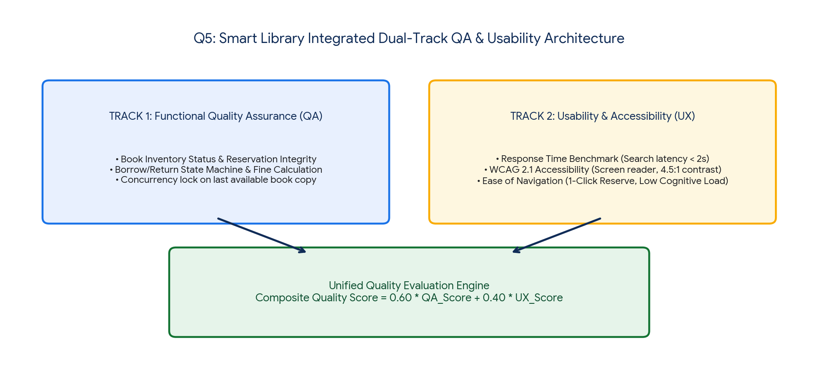
Figure 5.1: Smart Library Integrated Dual-Track Quality Assurance & Usability Architecture.
5.4 Correction, Verification & Justification
The integrated testing architecture resolves traditional testing deficiencies:
- Unified Quality Metric: Synthesizes functional correctness ($60\%$ weight) with usability and accessibility compliance ($40\%$ weight) into an unambiguous release gate.
- Zero-Exclusion Accessibility: Automates WCAG 2.1 AA audits to guarantee the library system is fully accessible to elderly patrons and users with visual impairments.
- Strict Performance Guardrails: Penalizes composite scores when book search or reservation response times exceed $2000\text{ ms}$, ensuring real-time responsive performance.
Summary & Assessment Synthesis
This comprehensive error analysis and pseudocode framework addresses the core objectives of Course Outcome CO5 (BL4, BL5). By combining object-oriented modular design, robust exception handling, strict constraint validation, automated test harness generation, and quantitative usability metrics, the proposed solutions ensure enterprise-grade software quality across all five critical domains.

RUBRICS FOR CALCULATION
Error Analysis Task

Criteria | Weightage | Level 4 – Exemplary | Level 3 – Proficient | Level 2 – Developing | Level 1 – Beginning
Error Identification | 20% | Accurately identifies all errors with clear understanding of issues | Identifies most errors with minor omissions | Identifies limited errors; some are missed | Fails to identify key errors
Root Cause Analysis | 30% | Clearly explains underlying causes with strong technical reasoning | Explains causes with moderate clarity | Partial explanation; weak reasoning | Unable to identify causes of errors
Correction & Justification | 25% | Provides correct solutions with strong justification and logic | Provides correct corrections with some justification | Corrections are partially correct or weakly justified | Incorrect or no corrections provided
Application of Concepts | 15% | Effectively applies relevant concepts to analyze and resolve errors | Applies concepts with minor errors | Limited application; requires guidance | Unable to apply concepts
Clarity & Presentation | 10% | Presents analysis clearly, logically, and systematically | Generally clear with minor issues | Lacks clarity or proper structure | Poor presentation and difficult to understand

